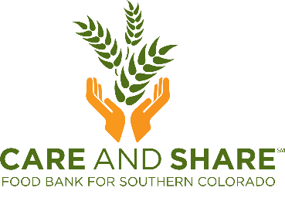

FOR IMMEDIATE RELEASE
[INSERT DATE]
MEDIA CONTACT:
[INSERT CONTACT INFORMATION]

[Organization Name] to Host Food Drive Benefitting Care and Share Food Bank for Southern Colorado

[City, State] – [Organization Name] is coming together to host a food drive for Care and Share Food Bank for Southern Colorado. From [start date] to [end date], donation barrels will be located at [barrel location] for people to donate non-perishable food items. Some of Care and Share’s most requested food items include canned protein, pre-packaged snacks, canned fruits and vegetables, and packaged meals like Hamburger Helper.
After the food drive has ended, Care and Share will make sure the donated food is sorted, packaged, and delivered to families, children, and individuals facing hunger.
[Optional paragraph for those collecting monetary donations online]: [Organization Name] is also collecting online donations. For every dollar donated to this campaign, Care and Share can provide 4 meals to neighbors in need. Together we can bridge the gap between hunger and abundance in Southern Colorado.

About Care and Share Food Bank
At Care and Share Food Bank, we believe that no one should go hungry. Every day, we provide food to our partner food pantries and meal sites across Southern Colorado to serve families, children, and seniors in need because well-fed communities are better for all of us. Care and Share is a member of Feeding America, a national food bank association. Every year, Care and Share distributes more than 25 million pounds of food to 289 partner agencies throughout 29 counties in Southern Colorado.

